Angular - Wildcard Route
This lab will discuss the Wildcard routes in Angular, including its syntax, usage and example of using in real-time angular project.

Wildcard Routes in Angular
In Angular, wildcard routes are used to match any path, whether it is valid or not. If the user navigates to an "invalid" or "undefined URL", you can use a wildcard route to catch that URL and navigate to a specified fallback component, such as Home, Login, or PageNotFound, depending on your application's needs.

Wildcard routes are defined using a double asterisk (**) symbol. This special route matches any URL that doesn't match any of the predefined routes in the route configuration.

Real-time Scenario
For example, if a user tries to access a path like /dashboard, which is not defined in the routes array, the wildcard route will match and can redirect them to a default or error component, such as a PageNotFound component.

Syntax of Angular Wildcard Routes
Below is the syntax to create a Angular Wildcard Routes
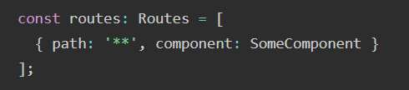
Here,
- **: The wildcard path that matches any URL, whether valid or invalid.
- SomeComponent: The component that will be rendered when the URL is invalid (e.g., Login, Home, or PageNotFound).

Example - Angular Wildcard Routes
- Create a new application app-wildcard-route. Open with VS Code.
- Create home component
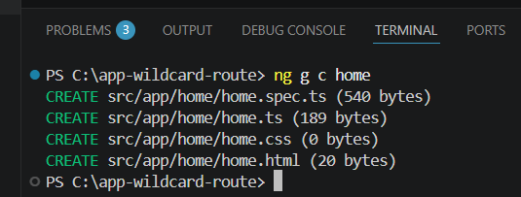

- Create about component.
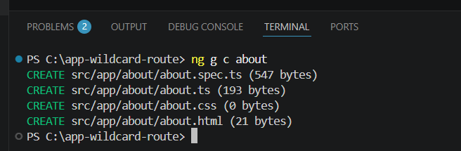
- Create view-item component.
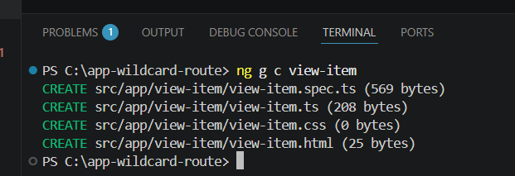
- Create a pagenotfound component
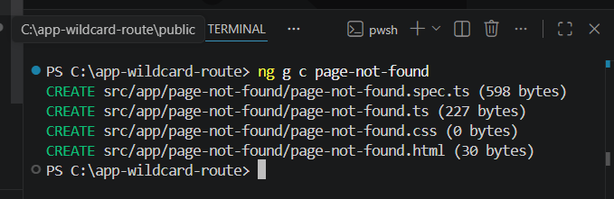
- In app.routes.ts
import { Routes } from '@angular/router';
import { Home } from './home/home';
import { About } from './about/about';
import { ViewItem } from './view-item/view-item';
import { PageNotFound } from './page-not-found/page-not-found';

export const routes: Routes = [
{path: '', component: Home},
{path: 'home', component: Home},
{path: 'about', component: About},
{path: 'view/:id', component: ViewItem},
{path: '**', component: PageNotFound}
];
- Add your routes to your application. In app.html
<h1>Angular Routing</h1>
<a routerLink="/home">Home</a><br />
<a routerLink="/about">About</a><br />
<a routerLink="/view/1">View Item1</a><br />
<a routerLink="/view/2">View Item2</a><br />
<router-outlet/>
- Now run the application and try to enter an invalid URL:
